PM5(6/7)xx – Residual Current Monitoring and AI(4-20mA)

High level Design



Version History
Version | Date | Author | Comments
1 | 13-Nov-2018 | Raju Dantuluri | Draft version
2 | 24-Nov-2018 | Raju Dantuluri | Updated with review comments
3 | 4-Dec-2018 | Raju Dantuluri | I2C command structure changed. Updated block diagrams.
Table of Contents

1 Purpose 3
2 High Level Block Diagram 3
3 Requirements: 4
3.1 For RCM board 4
3.2 For AI board 4
4 Functional Description: 4
4.1 RCM Feature 4
4.2 AI Feature 6
5 RCM / AI Firmware Architecture: 7
6 Microcontroller Details: 7
7 Firmware Interface Description: 8
8 I2C Communication: 9
8.1 Soft Reset: 10
8.2 Read Firmware Version 10
8.3 Go to Boot 10
8.4 Start Firmware Upgrade 11
8.5 Upgrade Firmware ID 11
8.6 Firmware Health 11
8.7 Measurement and status 12
8.8 Setup Data 12
8.9 Calibration 12

Purpose
.
This document is intended to provide high level firmware design details of RCM & AI boards in PM5660, PM5661, PM5760 and PM5761 series meters.

High Level Block Diagram

PM55xx
Metering Main Controller

Power Supply
Mains
Vcc

LCD Display

RCM / AI board
I2C
6V
I6
I5
Digital I/p
DI1
DI2
DO1
DO2

External Interface (Modbus, Web, SNMP etc)

For RCM:
Torroid 1:1000
For AI board
DC input 4-20mA
External Relay

I5, I6:- Residual and PE current measurements (0-1000mA Secondary) (for RCM board)
I5, I6:- DC inputs (4-20mA) (for AI board)
DI1, DI2:- 2 digital inputs
DO1, DO2: 2 digital outputs

Requirements:

For RCM board
Refer doc “DES-04_PM5XXX_RCM Specs-vx dd-mm-yyyy”

For AI board
Refer doc “TBD”

Functional Description:

RCM Feature
A residual-current monitoring device is a device that helps to monitor an electrical installation or circuit for the presence of an unbalanced earth fault current and to indicate, by means of alarm, the presence of a residual current when it exceeds a predetermined level. Residual currents are typically the result of insulation faults, leakage currents etc.

RCM feature is used to avoid unwanted events such as physical injuries, operation interrupts and fire. Continuous monitoring of residual currents helps for preventive maintenance and gain information regarding potential critical operating conditions at early stages, mainly to avoid fire damage and person injuries.
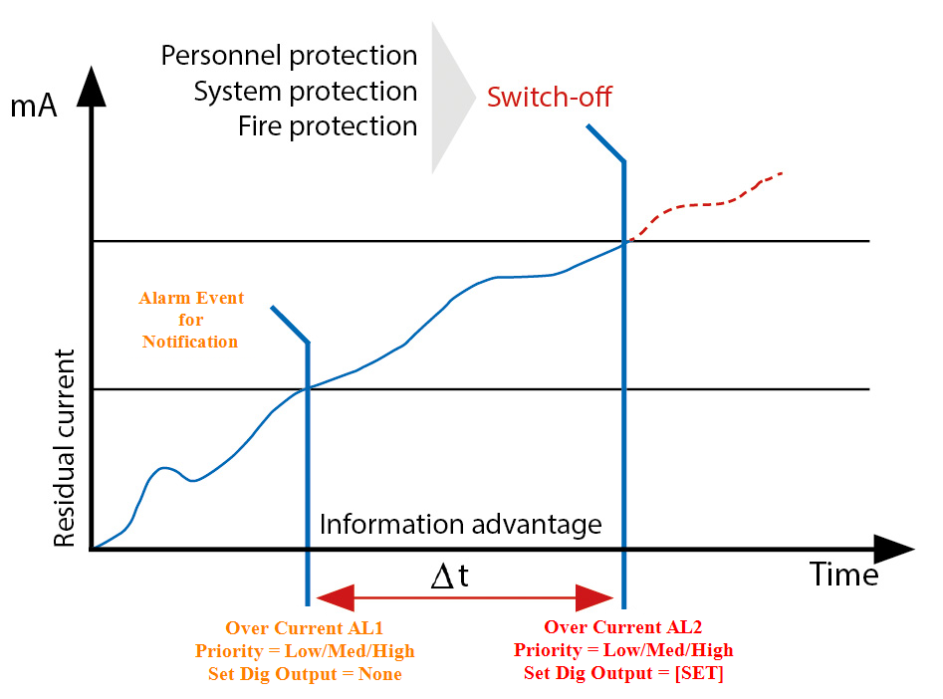

This current is calculated as the sum of the currents of all conductors, apart from the protective earth (PE), which feed into the system and is measured through a CT. If there is no fault in the system, the sum of all currents is equal to zero. If a fault flows via PE or other paths, the difference in current that is measured through CT are detected by RCM.
We support residual current monitoring on 2 channels i.e I5, I6 and the same will be displayed in LCD panel and signal an alarm when pre-set response values are exceeded.

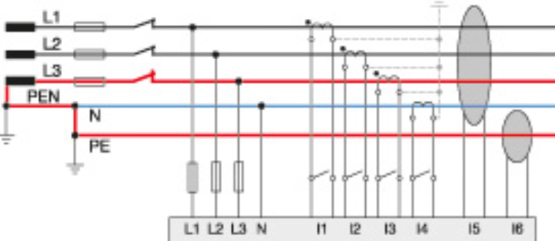

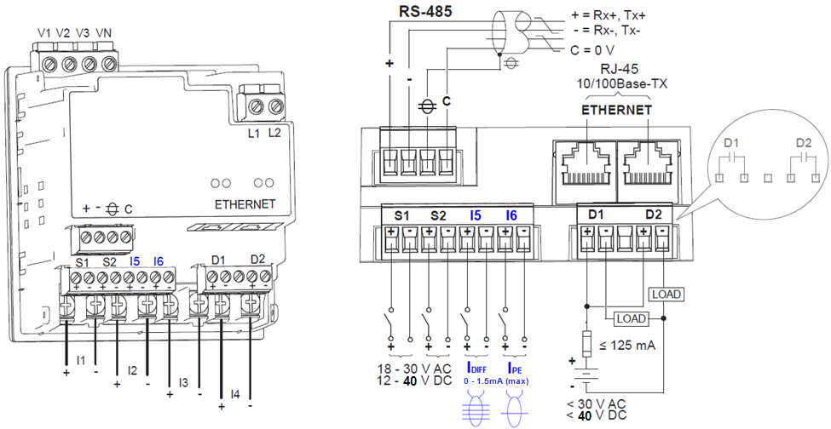

AI Feature
TBD

RCM / AI Firmware Architecture:

Below architecture diagram explain different firmware layers for RCM and AI boards in a high level. Hardware interfaces with low level drivers includes analog part, I/O control etc. All meteorology calculations include 1-cycle and 50 cycles will be done in metrology layer. As of now, Communication layer handles mainly I2C communication interface. Control layer performs the actions of handling digital outputs based on alarm thresholds, I2C data transfer initiation and control etc.

LOW Level drivers
Interrupt service routines (ISR)
Metrology layer
Control Layer
Hardware
BSP
Communication layer
RCM / AI Firmware Architecture

Microcontroller Details:
(MKM14Z128ACHH5)

KM family of devices is 32-bit MCUs in 90nm Thin Film Storage (TFS) embedded flash technology. These devices are primarily focused to serve the metering markets for smart energy meters. KM devices are based on 32-bit ARM Cortex M0+ core with integrated Analog Front End. CPU clock rates on these devices can reach up to 50 MHz The KM family of devices includes highly accurate Sigma Delta ADC, Programmable Gain Amplifier (PGA), high precision internal voltage reference, flash, RAM, and phase compensation logic block and other peripherals. KM family provides tamper detection and accurate real-time clock on all devices.

Firmware Interface Description:

MKM14Z128ACHH5 provides 4 channels ∑∆ 24 bit ADC and 24 channel 16 bit SAR ADC. RCM Platform uses ∑∆ ADC for current sampling and SAR for voltage sampling (5v and 3v). Sampled signals are read by the metrology block to calculate I5 and I6 parameters Sampling rate of the ADCs is controlled by the input frequency. Input frequency is mapped to either 50/60 Hz.
Frequency = 1/Tc

Samples/cycle (Sc) = 64 is selected to provide harmonic measurement up to 31st order of input frequency.
Sampling rate = Tc / Sc
Input frequency range will be the base frequency (50/60 Hz).

Core clock frequency will be 12MHz (1228800 Hz). Main clock is divided by 4 to get AFE clock frequency. Over sampling ratio(OSR) will be 64, with single conversion mode. Conversion time for single conversion is given by formula

Conversion time = AFE Setup time+(3*OSR*AFE clock)
As per datasheet minimum 20µsec AFE startup time to be provided.
With this Conversion time = 20 µsec + (3*64/3072 MHz) = 82.5 µsec

Digitized samples are read from ADC once conversion complete interrupt is received. Offset is subtracted from the sampled data to get bipolar digitized signal.

The RMS parameters are squared and summed sample by sample basis. Once predefined number of samples are accumulated, square root of average of squared sum is taken to get RMS of values of current.

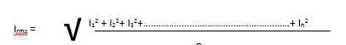
Where 1,2,3…………………..n number of samples

RCM firmware uses I2C driver to read setup parameters and to send measurements, alarm and relay status data to Main controller.

2 digital inputs which exists on board are directly communicates with main controller.
2 digital outputs are controlled by RCM/AI board based on alarm threshold settings.

Residual current measurements are done using by CT’s (1:1000). CT secondary current is dropped across the burden resistor. The dropped voltage across burden resistor is applied to the ADC. Differential input Sigma Delta ADC’s are used for current inputs.

The Voltage measurement is done by potential dividers. The output of the potential divider is applied to the ADC. Single ended SAR ADC’s are used for voltage inputs. These voltages are used to monitor 3v and 5v power satiability.

Single binary will be used for both RCM and AI boards. Firmware monitors a dedicated PIN to differentiate between boards.

I2C Communication:

RCM/AI board uses I2C communication to interface with main controller board.

Main Controller
(Master)
RCM/AI Controller
(Slave)
I2C

Speed: 100 kHZ
7- bit addressing
Rx and Tx Buffer size; 100 bytes
Master Address: 0x55
Slave Address: 0xAA
Data length :100 bytes

Read/write bit differentiates between whether master is sending data to the slave or requesting data from it.

We define and use first byte of data frame to identify different commands to get the necessary details from slave.

Commands are:

- Soft Reset: Initiates soft reset in slave
- Read firmware version: To get slave’s firmware version
- Go to boot: Moves from app mode to slave mode in slave
- Start firmware upgrade: Initiates firmware upgrade in slave
- Upgrade Firmware ID: Transfers the firmware and Checks whether the firmware is upgraded or not
- Firmware Health: Helps to check slave’s firmware health
- Reserved
- Measurements and Status: Helps to read measurements and status data from slave
- Setup data: Writes setup data to slave
- Calibration: Writes calibration data to slave

Soft Reset:
This command initiates SystemReset() functionality in slave.

Request ():

Tx[0] = eCmd_SoftResetId =1
Tx[1-4] = 0x0000A5A5u = BOOT_KEY
Tx[5] = no of bytes

Response ():

Rx[0] = eCmd_SoftResetId | 0x80
Rx[1] = status = True/false

Read Firmware Version
Request ():

Tx[0] = eCmd_ReadFWVersionId = 2
Tx[1] = no of bytes

Response ():

Rx[0] = eCmd_ReadFWVersionId | 0x80
Rx[1] = status = True/false
Rx[2] = 1/0
Rx[3-n] = Firmware version

Go to Boot
Request ():

Tx[0] = eCmd_GoToBootId= 3
Tx[1-4] = 0x0000A5A5u = BOOT_KEY
Tx[5] = no of bytes

Response ():

Rx[0] = eCmd_GoToBootId | 0x80
Rx[1] = status = True/false

Start Firmware Upgrade
Request ():

Tx[0] = eCmd_StartFirmwareUpgradeId= 4
Tx[1] = 1 // start firmware upgrade
Tx[2] = no of bytes

Response ():

Rx[0] = eCmd_StartFirmwareUpgradeId| 0x80
Rx[1] = status = True/false

Upgrade Firmware ID
Above command initiates and allows slave to upgrade firmware. This command transfers the firmware and checks whether the firmware is upgraded or not at the end.
Request ():

Tx[0] = eCmd_FirmwareUpgradeId = 5
Tx[1-4] = Address offset
Tx[5-6] = length
Tx[7- (n-2)] = Firmware data
Tx[(n-1)] = Buffer length
Tx[(n)] = eCmd_FirmwareUpgradeId

Response ():

Rx[0] = eCmd_ FirmwareUpgradeId | 0x80
Rx[1] = status = True/false
Rx[2-4] = Buff length

Firmware Health
Request ():

Tx[0] = eCmd_StartFirmwareUpgradeId= 6
Tx[1] = no of bytes

Response ():

Rx[0] = eCmd_StartFirmwareUpgradeId| 0x80
Rx[1] = status = True/false
Rx[2] = Firmware health = True/false

Measurement and status
Request ():

Tx[0] = eCmd_MeasurementsId = 8
Tx[1] = no of bytes

Response ():

Rx[0] = eCmd_ MeasurementsId | 0x80
Rx[1] = status = True/false
Rx[2-5] = I5 value
Rx[6-9] = I6 value
Rx[10-17] = Alarm status (4 alarms)
Rx[18- 21] = DO status (2 DO’s)

Setup Data
Request ():

Tx[0] = eCmd_SetupdataId= 9
Tx[1] = Status = True/false

Tx[2-25] = Alarm 1 status (enable – 2bytes, priority – 2 bytes, pickup pnt – 4bytes, pickup delay –
4bytes, Drop pnt – 4bytes, Drop delay – 4 bytes, DO association – 2 bytes,
Reserved – 2 bytes)
T[26-49] = Alarm 2 status
T[50-73] = Alarm 3 status
T[74-97] = Alarm 4 status

Response ():

Rx[0] = eCmd_SetupdataId | 0x80
Rx[1] = status = True/false

